**Developing Views and Apps for Splunk Web**

* **Custom Visualization in Splunk:**

Following the below reference, we were able to develop a sample custom visualization.

(Radial Meter) <https://docs.splunk.com/Documentation/Splunk/8.0.2/AdvancedDev/CustomVizTutorial>

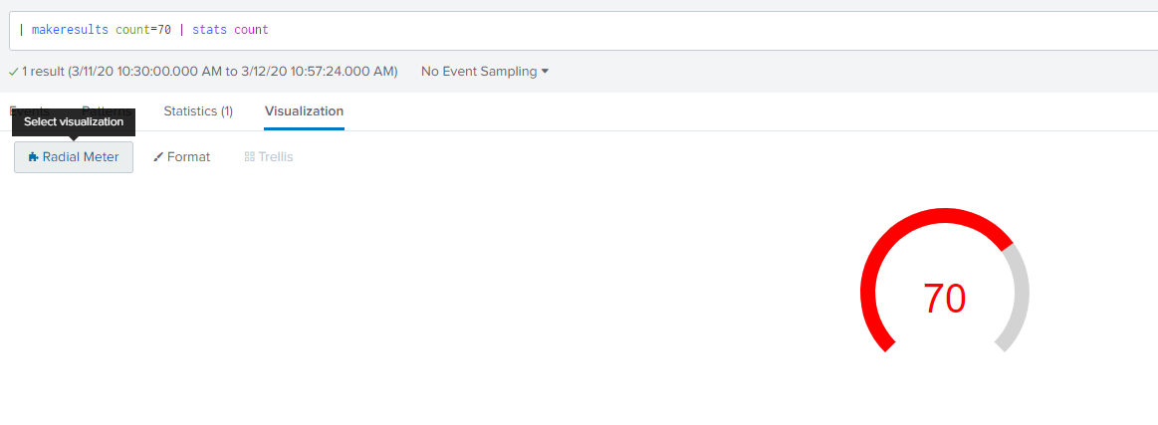

* **Custom Visualization Splunk JS:**

Following the below reference, we tried to utilize the custom visualization (Radial Meter) from SplunkJS. But this process fails to achieve our goal since the splunkjs stack libraries doesn’t have the relevant dependency needed.

The below html was used and deployed in my local **http-server**. It fails to locate 'splunkjs/mvc/visualizationregistry' from the SplunkJS stack. (html attached)

 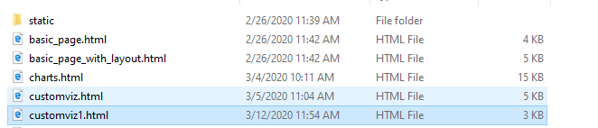

<https://docs.splunk.com/Documentation/Splunk/8.0.2/AdvancedDev/CustomVizSplunkJS>

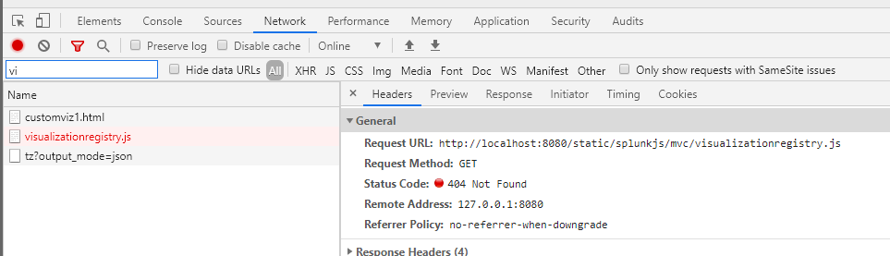

A similar issue – Not addressed

<https://answers.splunk.com/answers/682058/splunk-js-stack-custom-visualization-issue-renderi.html>

**Additional Notes –**

We checked the config.js available in splunkJS stack library and there are no references to ***visualizationregistry*** from /mvc pack. Instead, it’s available in /helpers pack which doesn’t provide much help to achieve our goal. There are no documentation available for the same.

**Result:**

Because of this hinderance, We need Splunk SME assistance to debug this further and determine the process of creating a custom visualization in SplunkJS and utilizing that in Angular+SplunkJS stack.

**Converted Dashboard HTML**

* **Dashboard converted to HTML:**

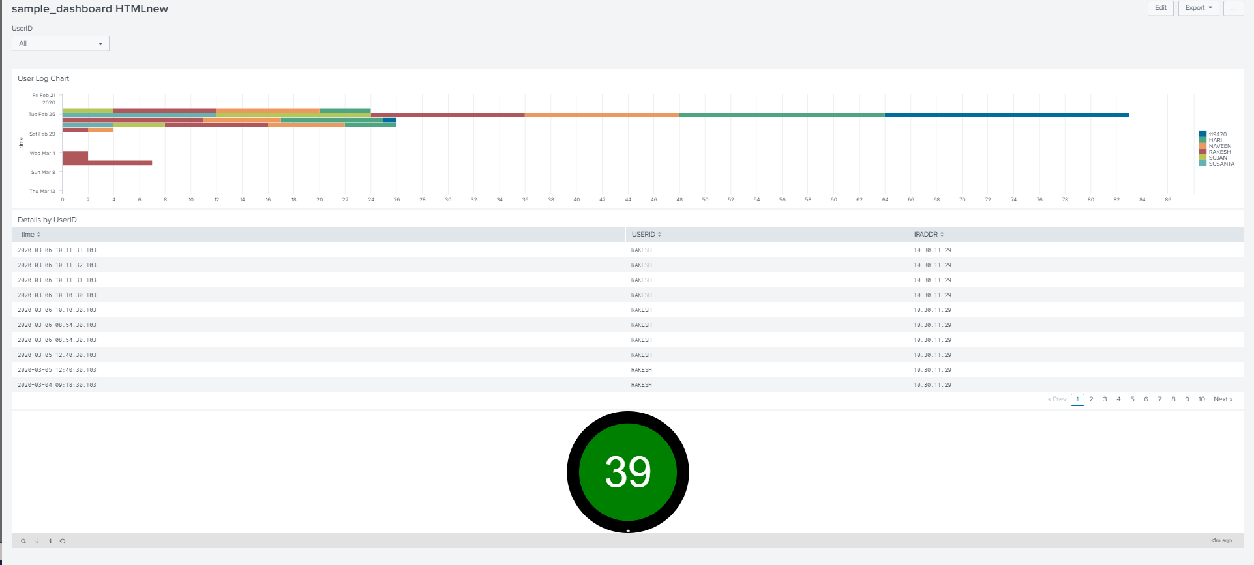

The converted HTML dashboard was taken as-is and deployed in http-server. It wouldn’t/doesn’t work since the splunk libraries referred are Splunk (***mvc/simplexml***) based libraries and not SplunkJS stack libraries.

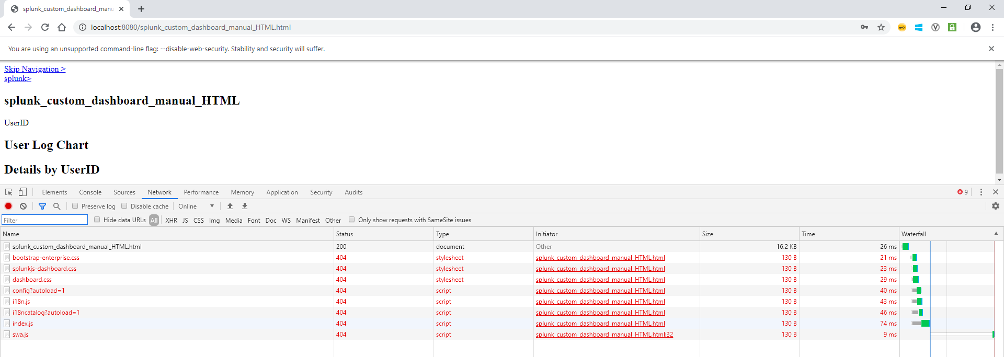

**HTML** - 

Ideally, our understanding is that, any converted HTML is to maintain/customize the dashboard in/for Splunk. And, it can’t be utilized in Splunk Web Apps as is.

We tried following the below documentation and was able to manually place new dashboards or update the dashboard.

<https://dev.splunk.com/enterprise/docs/developapps/webframework/usewebframework/convertsimplexml/>

I manually placed the HTML file under **$SPLUNK_HOME/etc/users/<username>/<appname>/local/data/ui/html**

C:\Program Files\Splunk\etc\users\rakesh\search**\local\data\ui\html**

**The Dashboard reflects in Splunk and it’s customizable further either from editor or Splunk.**

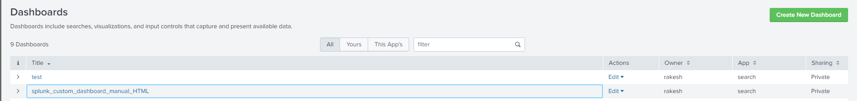

<https://dev.splunk.com/enterprise/docs/developapps/webframework/usewebframework/walkthroughautogenerated>

<https://dev.splunk.com/enterprise/tutorials/tutorialconvertsimple/>

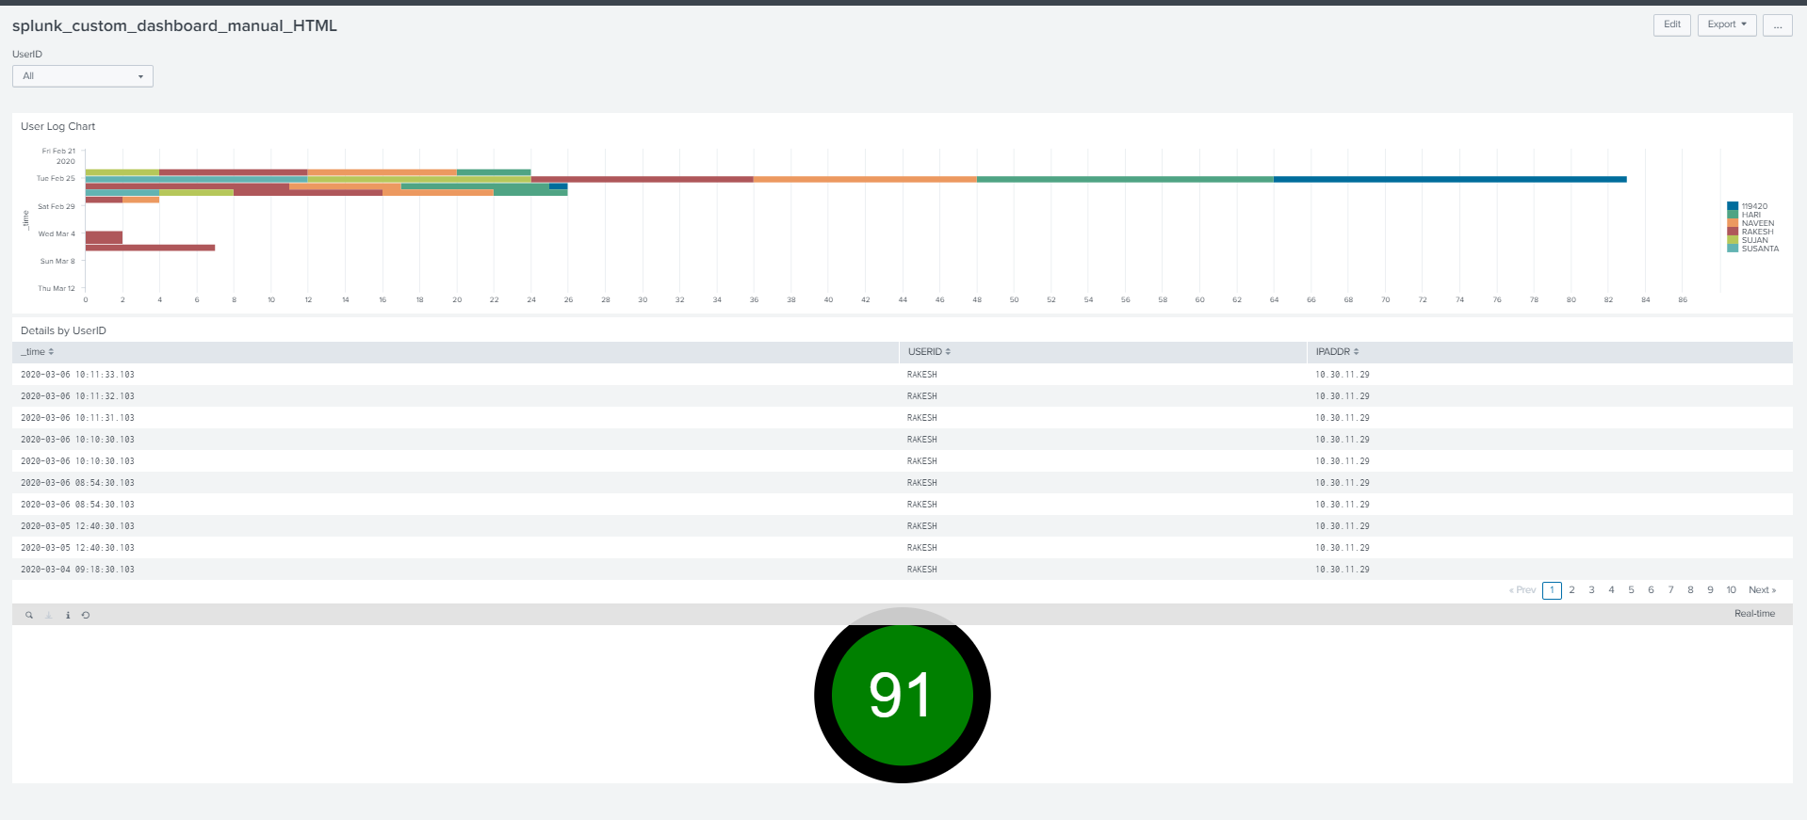

**Result:**

Based on the above, we need Splunk SME assistance to determine the procedure to utilize the Dashboard

HTML in External Web Apps as is.